RF and Microwave Design with JavaScript

Jerry Wiltz

Copyright © 2019 Jerry Wiltz

All rights reserved.

ISBN:

ISBN-13:

DEDICATION

For Marian, my Lúthien.

CONTENTS

|  |  |  |
| --- | --- | --- |
|  | Acknowledgments | i |
|  | Introduction |  |
| 1 | DC and Resistors | 1 |
| 2 | AC and Resistors, Inductors and Capacitors | Pg # |
| 3 | Chapter Name | Pg # |
| 4 | Chapter Name | Pg # |
| 5 | Chapter Name | Pg # |
| 6 | Chapter Name | Pg # |
| 7 | Chapter Name | Pg # |
| 8 | Chapter Name | Pg # |
| 9 | Chapter Name | Pg # |
| 10 | Chapter Name | Pg # |

ACKNOWLEDGMENTS

None.

1 DC and Resistors

This chapter begins with a review of DC theory and resistors. It reviews determining the total resistance of resistors in series: Rseries = R1 + R2 + R3 + …, it reviews determining the total resistance of resistors in parallel 1/Rparallel = 1/R1 + 1/R2 + 1/R3 + ... , and it reviews circuit analysis using voltage dividers. At this point, the arithmetic is straightforward. We will use all this review material to determine the resistance of a more complicated resistor network. So far, we are building on top what of the review material. Along the way, we review maximum power transfer, which is really the point of the whole thing.

All through this chapter, we will repeatedly analyze a resistor 3db attenuator 4 ways - all using DC theory. We do this to gain insight into network theory that is transferable to AC analysis. We will see that we can introduce the s-parameters at DC where the mathematics is much simpler and will set the stage to understand the s-parameters at AC with resistors, inductors, and capacitors covered in chapter 2.

We will analyze the 3dB attenuator using voltage dividers, using Kirchhoff’s Voltage Law, using Matrices, and finally using **nPort** all the while getting the same result. We perform hand calculations first to understand the theory better. After that, we see how simple it is to use **nPort** to accomplish the same thing. So we analyze by hand for learning and getting insight into circuit performance in order to use software, like **nPort**, knowing what to expect in advance.

**DC Review**

We start off with a basic circuit. This is the simplest circuit I can think of. It is shown in figure 1-1. It has a 1 volt DC source and a 1 Ohm resistor load. Note the current convention, current flows out of positive terminals of the source and moves in a clockwise direction.

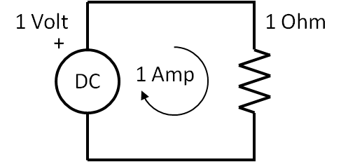

Figure 1-1 The Simplest Circuit

The current is 1 Amp from the equation. This is the **Ohm’s Law** equation.

|  |  |  |
| --- | --- | --- |
|  | $$I=\frac{V}{R}$$ | (1-1) |

For the values of V and R this this equation is very simple to solve as you mentally plug in 1 Volt over 1 Ohm to get 1 Amp.

Suppose there are two or more resistors are in series as shown in figure 1-2. We add them to determine Rseries

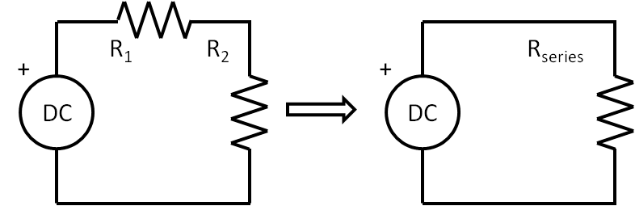

Figure 1-2 Resistors in series

The equation for the total resistance is the sum of all the resistors, and this is shown in equation 1-2.

|  |  |  |
| --- | --- | --- |
|  | $$R_{series}= R_{1}+ R_{2}$$ | (1-2) |

Likewise, if there are 2 or more resistors in parallel, as shown in figure 1-3, Rparallel now is inverse of the sum of the inverse of each resistor and is given by,

|  |  |  |
| --- | --- | --- |
|  | $$R_{parallel}= \frac{1}{\frac{1}{R_{1}}+\frac{1}{R_{2}}}$$ | (1-3) |

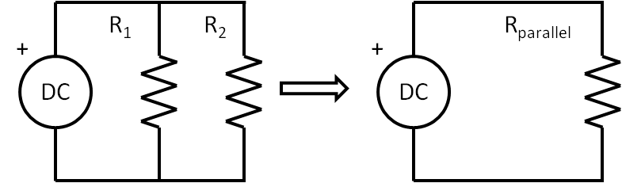

Figure 1-3 Resistors in parallel

Now we can determine the total resistance of a more complicated resistor network. A great many configurations of resistors can be combined into a single resistor by combining resistors that are in parallel and then adding to resistors in series. Keep doing this until there is one resistor left that is equivalent to the original network resistance, Requivalent. Take a look at the circuit shown in figure 1-4. You should work this out by hand to get insight and experience. You should work through them by hand at first.

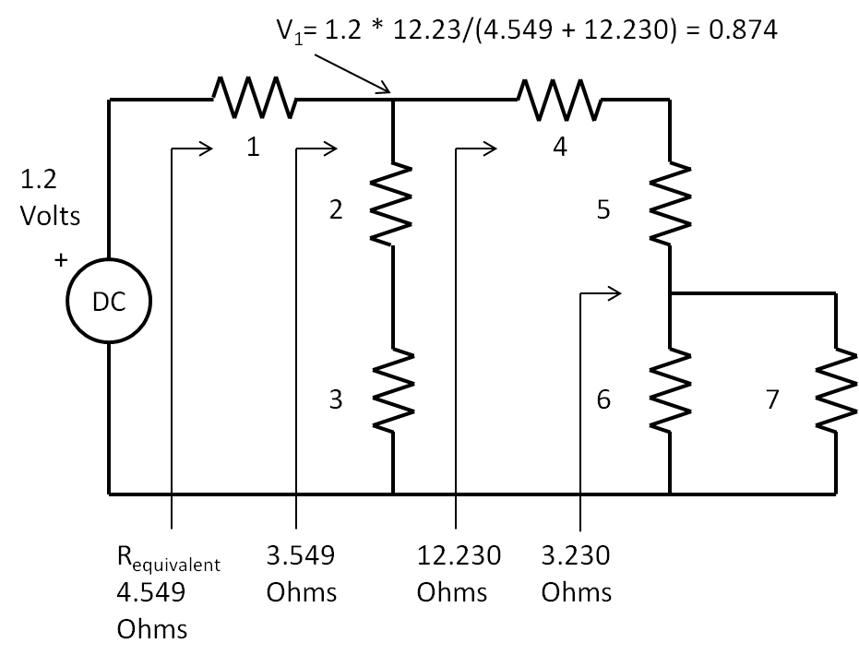

Figure 1-4 Finding the equivalent single resistor from seven resistors

I have included equivalent resistor values in figure 1-4, you should get those same results. Here is the total answer that I determined, Rtotal is 4.55 Ohms. Also, it is possible to use a larger equation written on one line that does everything,

|  |  |  |
| --- | --- | --- |
|  | $$4.549=1+1/(1/(4+5+1/(1/6+1/7))+1/(2+3))$$ | (1-4) |

Look at this equation and map the resistor values to the figure. You can see the parallel combination of the 6 and 7 Ohm resistors, then summing that with the 4 and 5 Ohm resistors, then putting that in parallel with the two series resistors of 2 and 3 Ohms, and finally adding that result with the series 1 Ohm resistor. Open up a browser such as Chrome. Then copy and paste the following into the search field: 1 + 1/( 1/(4 + 5+ 1/(1/6+1/7)) + 1/(2 + 3)). This wakes up the calculator that is part of the browser and boom, there is the result of 4.5591 Ohms. Pretty cool.

**Maximum Power Transfer**

Now we introduce the concept of Maximum Power Transfer from a source to a load. In the circuit shown in figure 1-5, the source is located inside the dotted line box that also contains a series resistor that is the internal resistance of the source. The load is connected across the terminals of the dotted line box. The load resistance value can be varied, say to a value lower than the internal resistor, or a higher value, or equal to the internal resistor value. We show these values in the table also in figure 1-6. This table has “educated guesses” for the load resistance and power is maximized when the load resistance is equal to the source resistance. So maximum power transfer occurs when **RSource = RLoad**. In the real world, there will always be a source resistance, no matter what, and power from the source will always be wasted and dissipated inside its own internal resistance. For now at DC, we define the value of the internal resistor to 50 Ohms. Power in an electrical circuit is the product of the voltage across a resistor and current flow through it. So for any resistor value, the power in Watts dissipated by it is,

|  |  |  |
| --- | --- | --- |
|  | $$P=V*I$$ | (1-5) |

As was mentioned, in the table of figure 1-5, there are some “educated guesses” of values of the load resistor, RLoad. The columns in the table show the value of load resistor and corresponding total current, the voltage across the load resistor and the power, in Watts, transferred to the load. The key observation that maximum power transfer occurs when the source resistance equals the load resistance. Notice the PLoad is greatest at RLoad = 50 Ohms and less than that if the RLoad is either less than or greater than 50 Ohms. Note also, if the source resistance is 50 Ohms, the load resistance must be 50 Ohms. Maximum power transfer is a fundamental concept in RF and microwave design.

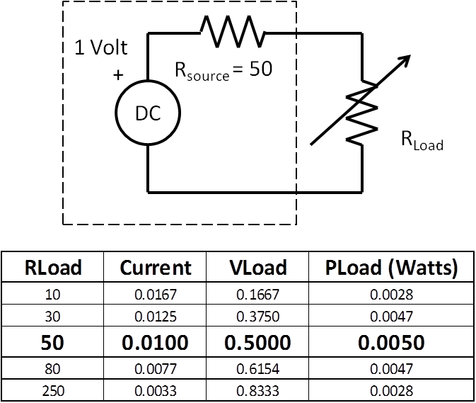

Figure 1-5 Maximum Power Transfer demo with “educated guesses” of load resistor values

Now we introduce the Through 2-port as shown in figure 1-6. Electrically, it is no different than the maximum power transfer circuit shown in figure 1-5. The circuit shown in figure 1-6 is a simple modification of figure 1-5. In this case, the Through 2-Port was inserted between the source and the load. The Through 2-port has four terminals, two terminals for each port. So for circuit with n number of ports, it has 2n terminals. With the Through 2-port in place, maximum power is transferred. As we proceed in this and the next chapters, we will replace the Through 2-port with more complicated 2-ports

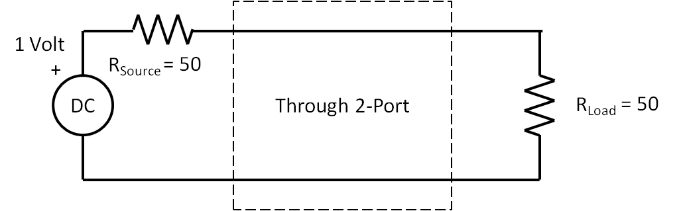

Figure 1-6 Showing the very simple Through 2-port, Power transfer is maximized.

What is the voltage at the load resistor in the circuit of figure 1-6? It is 0.5 Volts, right? Since the resistors are equal and in series, the same current flow through them and therefore they each have same voltage spread across them. There is a simple equation for this. This is the voltage divider equation.

|  |  |  |
| --- | --- | --- |
|  | $$V_{Load}=V_{Source}*\frac{R_{Load}}{R_{Source}+R_{Load}}=1*\frac{50}{100}=0.5V$$ | (1-6) |

**The 3dB Attenuator**

Figure 1-7 shows the schematic of a 3dB attenuator that we will analyze by several methods. One of goals of this chapter is to analyze this circuit for attenuation by hand and then by JavaScript. As you will see, hand analysis is tedious and error prone even for this basic circuit. Using JavaScript for everything is the goal. However, spending time with the hand analysis is vital because that is what will train you to understand what is happening. It’s like learning to cook, you have to cook and experience the way food works, only then can you create brand new dishes. Similarly, you have to experience how the equations work, only then can create brand new circuits. Moreover, working through things by hand at first will give you insight and will give you a notion of what to expect rather than blindly using computers and software while being unaware of what to do next when you don’t get expected results. So we will begin, first, to analyze the 3dB attenuator circuit shown in figure 1-7 by first using the voltage divider technique. Second, we will use Kirchhoff’s voltage law to solve it by hand, and third, we will use JavaScript. Forth, we will analyze it with **nPort’s** matrix functions (see figure 1-10 for these cases). Last, we will analyze the attenuator with **nPort** s-parameter functions. As we proceed with the hand analysis, there are a lot of equations to solve. So as we transition from hand analysis, notice how few lines of code required. However, the hand analysis gives insight as to what to expect the answer to be before we use nPort.

We start the hand analysis of the 3dB attenuator by using the voltage divider technique. The basic voltage divider formula is shown in equation 1-6. The schematic for the 3dB attenuator is shown in figure 1-7. The first steps are to combine R1, R2, R3, and RLoad into one resistor, RV1. The next step is to plug RSource and RV1 into equation 1.6 and find V1. The next step is to find RV2 from R3 and RLoad. Next use V1, R2, and RV2 in the voltage divider equation and find V2. Let us attempt to find the interior voltages V1 and V2 of the network shown in figure 1-8.

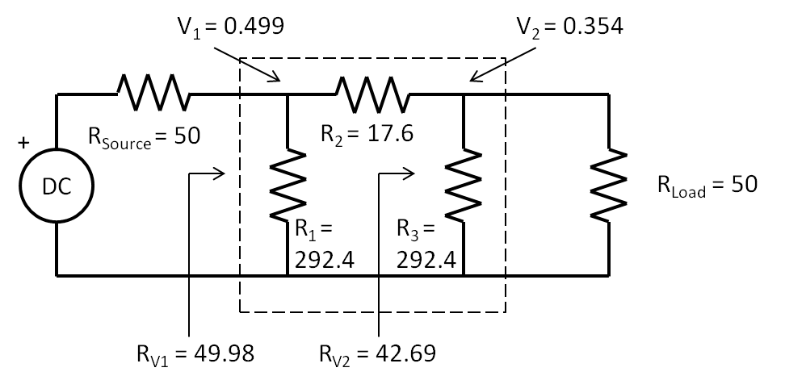

Figure 1-7 Schematic of a 3 dB Attenuator between a source and load

First, find the RV1 for R1,R2,R3, and RLoad using the techniques of the resistance of a complicated circuit such that of figure 1.4.

|  |  |  |
| --- | --- | --- |
|  | $$R_{V1}=\frac{1}{\frac{1}{292.4}+\frac{1}{17.6+\frac{1}{\frac{1}{292.4}+\frac{1}{50}}}}=49.98$$ | (1-7) |

Second, now we use the voltage divider equation to find V1

|  |  |  |
| --- | --- | --- |
|  |  | (1-8) |

Third, find RV2 by finding parallel resistance of R3 and RLoad

|  |  |  |
| --- | --- | --- |
|  |  | (1-9) |

Fourth and lastly, find V2 using the voltage divider formula and V1 along with R2 and RV2

|  |  |  |
| --- | --- | --- |
|  |  | (1-10) |

You should work through the above analysis by hand. So you should get the same answers for V1 and V2 in whatever methods you try. Here is something interesting and important to try. Plugin V1 and V2 into this formula and paste it into your browser. Attenuation or reduction in voltage in dB is

|  |  |  |
| --- | --- | --- |
|  | $$20*\log\left(\frac{V_{2}}{V_{1}}\right)=20*\log\left(\frac{0.354}{0.499}\right)=-2.997dB$$ | (1-11) |

You should get Attenuation in dB of -2.997. We will describe the notation, dB or Decibel in the next section, do you don’t have to worry too much if you have never heard of it before. Next, repeat the analysis with values of R1 = R3 = 96.25 Ohms and R2 = 71.15 Ohms. In this new situation, did you notice that V1 did not change? It is still 0.5 Volts. Why? Because R1, R2, R3 are adjusted for maximum power transfer and RV1 is the same. Also if you took 20*log10(V2/V1) in this situation, you should get 10dB for attenuation.

**Interlude: The Decibel**

In equation 1-11, we just expressed the ratio of V2/V1 as -3dB, in dB as meaning in decibels. Why do this? Why the decibel? What does that -3dB number mean and where did it come from? Now what do we mean by -3dB?

In the schematic shown in figure 1-7, there is maximum power transfer since RV1 = RSource=50 Ohms. You should verify the current through RV1 is 0.1 Amps and the power dissipated by RV1 is 0.05 Watts. The current through RLoad is V2/RLoad is 0.354/50 which is 0.0078 Amp and the power dissipated by RLoad is 0.0025 Watts. This means that from the 0.05 Watts available, only 0.0025 Watts of power transferred to the load, or half the power. So -3dB means that half the power, entering the attenuator, makes it out of the attenuator.

Historically, back in the days of the early telephone, and due to the large range of the ratios of power gains and losses of telephone transmission lines and systems, it became more practical to plot on paper these ratios with log scales. In honor of Alexander Graham Bell, the unit for this log of ratios was named the ***bel.*** To make the plotting even easier the ***bel*** was multiplied by 10 to give the new unit, the ***decibel.*** A decibel is defined as one tenth of a bel. That’s why we multiply by 10. Now why did we multiply by 20 in equation 1-11 instead of 10? The decibel is 10 * log of a power ratio. But the ratio in equation 1-11 is a voltage ratio. Since these are voltages across resistors, we need to obtain the power dissipated by the resistors. Since,

|  |  |  |
| --- | --- | --- |
|  | $$I=\frac{V}{R}$$ | (1-12) |

and,

|  |  |  |
| --- | --- | --- |
|  | $$P=V*I$$ | (1-13) |

therefore,

|  |  |  |
| --- | --- | --- |
|  | $$P=V*\frac{V}{R}=\frac{V^{2}}{R}$$ | (1-14) |

Notice that V squared in the numerator, taking the log of a number raised to a power, the power multiplies the log of the base.

|  |  |  |
| --- | --- | --- |
|  | $$10*\log\left({4.52}^{2}\right)=2*10*\log\left(4.5\right)= 20*\log\left(4.5\right)$$ | (1-15) |

So just remember, when dealing with voltages, use 20*log, when dealing with powers, use 10*log. For far more info check the wiki page on the [decibel](https://en.wikipedia.org/wiki/Decibel).

If you think of an RF system as blocks chained together and each blocks has either a gain or a loss, then you could determine the overall gain or loss by multiplying all the individual stages together. But that is really messy. Much easier to use dB’s because we add them rather than multiply them, the log of multiplied numbers is equal to the addition of the log of each stage. Suppose there is a very simple RF system that has two blocks. The first block is an amplifier with a gain of 177. The second block is long cable that has a loss of 0.707. The overall gain is 177 times 0.707 = 125. But look,

|  |  |  |
| --- | --- | --- |
|  | $$20\log\left(177*0.707\right)=20\log\left(177\right)+20log⁡(0.707)$$ | (1-16) |

Or

|  |  |  |
| --- | --- | --- |
|  | $$42dB=45dB-3dB$$ | (1-17) |

Suppose there are dozens of blocks to make up an RF system. It is much easier thinking in dB’s and adding than thinking of multiplying huge or tiny number together.

One of the things seasoned RF types could do is dB arithmetic in their heads. It takes a little memorization and practice. The memorization part is knowing the logs of x=1 through x=10 by heart and seeing how this maps out for logs of 1/x as shown in the table below.

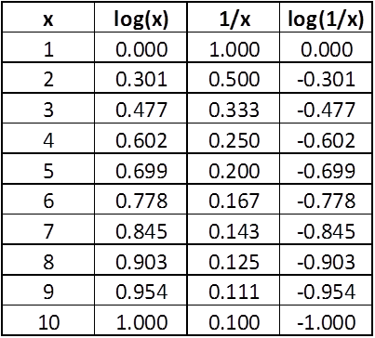

So let’s redo the amplifier gain of 177 and cable loss of 0.707, quickly and approximately in our head, assuming we have memorized and practiced. For the amplifier gain, 177 is 1.77 * 100, so using the memorized table 1.77 is close to 2 and the log of 2 is close to 0.3; the log of 100 is 2, so we add the logs 0.3 to 2 to get 2.3 and then multiply by 20 to get 46 dB gain for the amplifier. Similarly for the cable loss, 0.707 is 7 * 1/10, so the log of 7 is about 0.8 and the log of 1/10 is -1.0, obtaining the sum of 0.8 - 1.0 to get -0.2 and multiply by 20 to get -4 dB loss for the cable. Lastly, to obtain the overall gain of this RF system we add 46 dB to - 4 dB to get 42 dB. It is the same result as in equation (1-17). So, by expressing large or small numbers as a number between 1 and 10 with multiples of  10 or 1/10, (This is called scientific notation) using logs we can reduce long chains of multiplication to simpler chains of addition. The decibel is used all over the place in RF and Microwave.

**Kirchhoff’s Voltage Law**

If you done the hand calculations thus far, you are realizing how tedious and mistake prone all this arithmetic can be. It would be great to mechanize this into forms that a computer could read and let a program to all the work. Since we are analysing DC, the tedious analysis is performed only one time. However when we are analysing AC, the analysis must be performed for each frequency point, so computer solutions are even more important.

So now we begin to form a foundation for mechansing these analyses and using computer and software to do all the work. First, we will talk about Kirchhoff’s Voltage Law identifying and setting up the loop currents and voltage drops across resistors. Second, will introduce the resistor matrix to solve for currents and use **nPort** to easily do this. Third, we will use the currents to solve for the voltages of interest and take their ratios. Lastly, we will express these ratios in dB and get the same result as we did for the voltage divider technique.

Starting with Kirchhoff’s Voltage Law: for a closed loop series path the algebraic sum of all the voltages around any closed loop in a circuit is equal to zero. In figure 1-8, there is one closed current loop and the Kirchhoff’s Voltage Law equation for this situation is

|  |  |  |
| --- | --- | --- |
|  | $$V-I*R=0$$ | (1-18) |

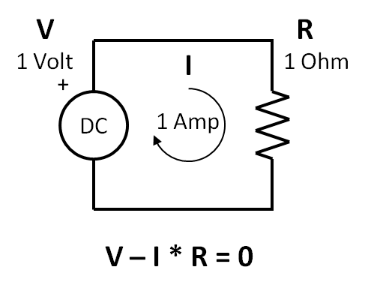

Figure 1-9 Simple schematic showing Kirchhoff’s Voltage Law.

Listing 1.1 below shows JavaScript in the body section of an .html page. You should create a file named index.html and camp there until can see the 1 Amp result for the current, I, in the console window. **Make sure you can do all of this before going further.** You should get this listing to run in your browser, you should see the output in the console of your browser. Now would be a good time to learn you to use some of the console. I use YouTube a lot to learn about these things. So have at it.

Listing 1-1 Simple JavaScript and Kirchhoff’s Voltage Law.

<!DOCTYPE html>

<html>

<head>

<title>Listing 1-1 Kirchhoffs Voltage Law</title>

</head>

<body>

<script>

// Kirchhoff voltage law: The sum of the voltages around a loop is 0 or V - I*R = 0;

// define the resistor and voltage source

var R = 1, V = 1, I = 0;

// solve for I, if V - I*R = 0, then  V = I*R and I = V/R

I = V/R;

// use console.log to display I, and in this case, I = a1

console.log('The loop current is ...');

console.log(I+' Amp');

</script>

</body>

</html>

Do you know how to use the console in your browser now? I am assuming you know how by now.

Next, and knowing how to see JavaScript results on console of the browser, we analyse the 3 dB attenuator a second way. Let us apply Kirchhoff’s Voltage Law to the 3 dB Attenuator first shown in figure 1-8. We redraw it in figure 1-10 to show the three current loops and apply Kirchhoff’s Voltage Law for each loop.

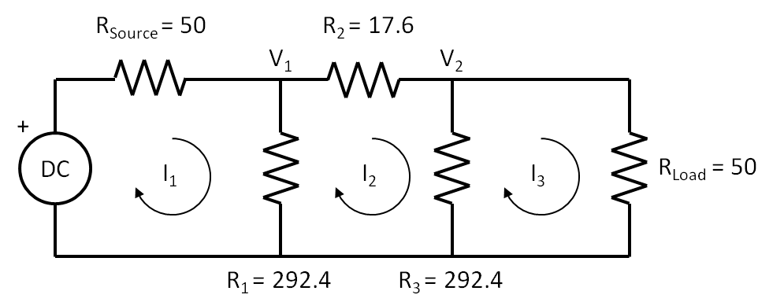

Figure 1-10 3dB Attenuator analysis using Kirchhoff’s Voltage Law

**Don’t Panic!** Matrices are coming up. But we will use JavaScript to do the work. So let’s write the three equations, one equation for each current loop. You can see in equations 1-19 that there are 3 equations and 3 unknowns, I1, I2, and I3.

|  |  |  |
| --- | --- | --- |
|  |  | (1-19) |

Look at the first line of equation 1-19. There are 2 resistors that carry I1: Rsource and R1 and there is an adjacent current loop carrying I2 through a common resistor, R1. Note, I2 is flowing opposite I1 and the actual current through R1 is I1-I2. Also notice that each equation must contain terms that have all the currents. I1 and I2 matter in the first line of equation 1-19, but not I3 since the first and third loops do not touch. In the second line in equation 1-19, all the currents matter since loop2 is adjacent to loops 1 and 3.

Next we rearrange equation 1-19 by putting the source voltages on the left side and apply distributive law on right side that shows sums of resistors multiplied by currents. This result is shown in equation 1-20.

|  |  |  |
| --- | --- | --- |
|  |  | (1-20) |

So finally, let's put equations 1-20 in matrix form of **V = R * I**

|  |  |  |
| --- | --- | --- |
|  | $$\left[\begin{matrix}V \\ 0 \\ 0\end{matrix}\right]=\left[\begin{matrix}Rsource+R1 & -R1 & 0 \\ -R1 & R1+R2+R3 & -R3 \\ 0 & -R3 & R3+Rload\end{matrix}\right]*\left[\begin{matrix}I1 \\ I2 \\ I3\end{matrix}\right]$$ | (1-21) |

2 CHAPTER NAME

Insert chapter two text here. Insert chapter two text here. Insert chapter two text here. Insert chapter two text here. Insert chapter two text here. Insert chapter two text here. Insert chapter two text here. Insert chapter two text here. Insert chapter two text here. Insert chapter two text here. Insert chapter two text here. Insert chapter two text here. Insert chapter two text here.

Insert chapter two text here. Insert chapter two text here. Insert chapter two text here. Insert chapter two text here. Insert chapter two text here. Insert chapter two text here. Insert chapter two text here. Insert chapter two text here. Insert chapter two text here. Insert chapter two text here. Insert chapter two text here. Insert chapter two text here. Insert chapter two text here. Insert chapter two text here. Insert chapter two text here. Insert chapter two text here. Insert chapter two text here. Insert chapter two text here. Insert chapter two text here. Insert chapter two text here. Insert chapter two text here. Insert chapter two text here. Insert chapter two text here. Insert chapter two text here. Insert chapter two text here. Insert chapter two text here. Insert chapter two text here. Insert chapter two text here. Insert chapter two text here. Insert chapter two text here. Insert chapter two text here.

Insert chapter two text here. Insert chapter two text here. Insert chapter two text here. Insert chapter two text here. Insert chapter two text here. Insert chapter two text here. Insert chapter two text here. Insert chapter two text here. Insert chapter two text here. Insert chapter two text here. Insert chapter two text here. Insert chapter two text here. Insert chapter two text here. Insert chapter two text here. Insert chapter two text here. Insert chapter two text here. Insert chapter two text here. Insert chapter two text here.

Insert chapter two text here. Insert chapter two text here. Insert chapter two text here. Insert chapter two text here. Insert chapter two text here. Insert chapter two text here. Insert chapter two text here. Insert chapter two text here. Insert chapter two text here. Insert chapter two text here. Insert chapter two text here. Insert chapter two text here. Insert chapter two text here. Insert chapter two text here. Insert chapter two text here. Insert chapter two text here. Insert chapter two text here. Insert chapter two text here.

Insert chapter two text here. Insert chapter two text here. Insert chapter two text here. Insert chapter two text here. Insert chapter two text here. Insert chapter two text here. Insert chapter two text here. Insert chapter two text here. Insert chapter two text here. Insert chapter two text here. Insert chapter two text here.

Insert chapter two text here. Insert chapter two text here. Insert chapter two text here. Insert chapter two text here. Insert chapter two text here. Insert chapter two text here. Insert chapter two text here. Insert chapter two text here. Insert chapter two text here. Insert chapter two text here. Insert chapter two text here. Insert chapter two text here. Insert chapter two text here. Insert chapter two text here. Insert chapter two text here.

Insert chapter two text here. Insert chapter two text here. Insert chapter two text here. Insert chapter two text here. Insert chapter two text here. Insert chapter two text here. Insert chapter two text here. Insert chapter two text here. Insert chapter two text here. Insert chapter two text here. Insert chapter two text here. Insert chapter two text here. Insert chapter two text here. Insert chapter two text here. Insert chapter two text here. Insert chapter two text here. Insert chapter two text here. Insert chapter two text here. Insert chapter two text here. Insert chapter two text here. Insert chapter two text here. Insert chapter two text here. Insert chapter two text here.

Insert chapter two text here. Insert chapter two text here. Insert chapter two text here. Insert chapter two text here. Insert chapter two text here. Insert chapter two text here. Insert chapter two text here. Insert chapter two text here. Insert chapter two text here. Insert chapter two text here. Insert chapter two text here. Insert chapter two text here. Insert chapter two text here. Insert chapter two text here. Insert chapter two text here. Insert chapter two text here. Insert chapter two text here. Insert chapter two text here.

3 CHAPTER NAME

Insert chapter three text here. Insert chapter three text here. Insert chapter three text here. Insert chapter three text here. Insert chapter three text here. Insert chapter three text here. Insert chapter three text here. Insert chapter three text here. Insert chapter three text here. Insert chapter three text here. Insert chapter three text here. Insert chapter three text here.

Insert chapter three text here. Insert chapter three text here. Insert chapter three text here. Insert chapter three text here. Insert chapter three text here. Insert chapter three text here. Insert chapter three text here. Insert chapter three text here. Insert chapter three text here. Insert chapter three text here. Insert chapter three text here. Insert chapter three text here.

Insert chapter three text here. Insert chapter three text here. Insert chapter three text here. Insert chapter three text here. Insert chapter three text here. Insert chapter three text here. Insert chapter three text here. Insert chapter three text here. Insert chapter three text here. Insert chapter three text here. Insert chapter three text here. Insert chapter three text here. Insert chapter three text here. Insert chapter three text here. Insert chapter three text here. Insert chapter three text here. Insert chapter three text here. Insert chapter three text here. Insert chapter three text here. Insert chapter three text here. Insert chapter three text here. Insert chapter three text here. Insert chapter three text here. Insert chapter three text here. Insert chapter three text here. Insert chapter three text here. Insert chapter three text here. Insert chapter three text here. Insert chapter three text here. Insert chapter three text here. Insert chapter three text here. Insert chapter three text here. Insert chapter three text here. Insert chapter three text here. Insert chapter three text here. Insert chapter three text here.

Insert chapter three text here. Insert chapter three text here. Insert chapter three text here. Insert chapter three text here. Insert chapter three text here. Insert chapter three text here. Insert chapter three text here. Insert chapter three text here. Insert chapter three text here. Insert chapter three text here. Insert chapter three text here. Insert chapter three text here. Insert chapter three text here. Insert chapter three text here. Insert chapter three text here. Insert chapter three text here. Insert chapter three text here. Insert chapter three text here. Insert chapter three text here. Insert chapter three text here. Insert chapter three text here. Insert chapter three text here. Insert chapter three text here. Insert chapter three text here. Insert chapter three text here. Insert chapter three text here. Insert chapter three text here. Insert chapter three text here. Insert chapter three text here. Insert chapter three text here. Insert chapter three text here. Insert chapter three text here. Insert chapter three text here. Insert chapter three text here. Insert chapter three text here. Insert chapter three text here.

Insert chapter three text here. Insert chapter three text here. Insert chapter three text here. Insert chapter three text here. Insert chapter three text here. Insert chapter three text here. Insert chapter three text here. Insert chapter three text here. Insert chapter three text here. Insert chapter three text here. Insert chapter three text here. Insert chapter three text here. Insert chapter three text here. Insert chapter three text here. Insert chapter three text here. Insert chapter three text here. Insert chapter three text here. Insert chapter three text here. Insert chapter three text here. Insert chapter three text here. Insert chapter three text here. Insert chapter three text here. Insert chapter three text here. Insert chapter three text here. Insert chapter three text here. Insert chapter three text here. Insert chapter three text here. Insert chapter three text here. Insert chapter three text here. Insert chapter three text here. Insert chapter three text here. Insert chapter three text here. Insert chapter three text here. Insert chapter three text here. Insert chapter three text here. Insert chapter three text here.

Insert chapter three text here. Insert chapter three text here. Insert chapter three text here. Insert chapter three text here. Insert chapter three text here. Insert chapter three text here. Insert chapter three text here. Insert chapter three text here. Insert chapter three text here. Insert chapter three text here. Insert chapter three text here. Insert chapter three text here. Insert chapter three text here. Insert chapter three text here. Insert chapter three text here. Insert chapter three text here. Insert chapter three text here. Insert chapter three text here. Insert chapter three text here. Insert chapter three text here. Insert chapter three text here. Insert chapter three text here. Insert chapter three text here. Insert chapter three text here. Insert chapter three text here. Insert chapter three text here. Insert chapter three text here. Insert chapter three text here. Insert chapter three text here. Insert chapter three text here. Insert chapter three text here. Insert chapter three text here. Insert chapter three text here. Insert chapter three text here. Insert chapter three text here. Insert chapter three text here.

Insert chapter three text here. Insert chapter three text here. Insert chapter three text here. Insert chapter three text here. Insert chapter three text here. Insert chapter three text here. Insert chapter three text here. Insert chapter three text here. Insert chapter three text here. Insert chapter three text here. Insert chapter three text here. Insert chapter three text here. Insert chapter three text here. Insert chapter three text here. Insert chapter three text here. Insert chapter three text here. Insert chapter three text here. Insert chapter three text here. Insert chapter three text here. Insert chapter three text here. Insert chapter three text here. Insert chapter three text here. Insert chapter three text here. Insert chapter three text here. Insert chapter three text here. Insert chapter three text here. Insert chapter three text here. Insert chapter three text here. Insert chapter three text here. Insert chapter three text here. Insert chapter three text here. Insert chapter three text here. Insert chapter three text here. Insert chapter three text here. Insert chapter three text here. Insert chapter three text here.

4 CHAPTER NAME

Insert chapter four text here. Insert chapter four text here. Insert chapter four text here. Insert chapter four text here. Insert chapter four text here. Insert chapter four text here. Insert chapter four text here. Insert chapter four text here. Insert chapter four text here. Insert chapter four text here. Insert chapter four text here. Insert chapter four text here.

Insert chapter four text here. Insert chapter four text here. Insert chapter four text here. Insert chapter four text here. Insert chapter four text here. Insert chapter four text here. Insert chapter four text here. Insert chapter four text here. Insert chapter four text here. Insert chapter four text here. Insert chapter four text here. Insert chapter four text here.

Insert chapter four text here. Insert chapter four text here. Insert chapter four text here. Insert chapter four text here. Insert chapter four text here. Insert chapter four text here. Insert chapter four text here. Insert chapter four text here. Insert chapter four text here. Insert chapter four text here. Insert chapter four text here. Insert chapter four text here. Insert chapter four text here. Insert chapter four text here. Insert chapter four text here. Insert chapter four text here. Insert chapter four text here. Insert chapter four text here. Insert chapter four text here. Insert chapter four text here. Insert chapter four text here. Insert chapter four text here. Insert chapter four text here. Insert chapter four text here. Insert chapter four text here. Insert chapter four text here. Insert chapter four text here. Insert chapter four text here. Insert chapter four text here. Insert chapter four text here. Insert chapter four text here. Insert chapter four text here. Insert chapter four text here. Insert chapter four text here. Insert chapter four text here. Insert chapter four text here.

Insert chapter four text here. Insert chapter four text here. Insert chapter four text here. Insert chapter four text here. Insert chapter four text here. Insert chapter four text here. Insert chapter four text here. Insert chapter four text here. Insert chapter four text here. Insert chapter four text here. Insert chapter four text here. Insert chapter four text here. Insert chapter four text here. Insert chapter four text here. Insert chapter four text here. Insert chapter four text here. Insert chapter four text here. Insert chapter four text here. Insert chapter four text here. Insert chapter four text here. Insert chapter four text here. Insert chapter four text here. Insert chapter four text here. Insert chapter four text here. Insert chapter four text here. Insert chapter four text here. Insert chapter four text here. Insert chapter four text here. Insert chapter four text here. Insert chapter four text here. Insert chapter four text here. Insert chapter four text here. Insert chapter four text here. Insert chapter four text here. Insert chapter four text here. Insert chapter four text here.

Insert chapter four text here. Insert chapter four text here. Insert chapter four text here. Insert chapter four text here. Insert chapter four text here. Insert chapter four text here. Insert chapter four text here. Insert chapter four text here. Insert chapter four text here. Insert chapter four text here. Insert chapter four text here. Insert chapter four text here. Insert chapter four text here. Insert chapter four text here. Insert chapter four text here. Insert chapter four text here. Insert chapter four text here. Insert chapter four text here. Insert chapter four text here. Insert chapter four text here. Insert chapter four text here. Insert chapter four text here. Insert chapter four text here. Insert chapter four text here. Insert chapter four text here. Insert chapter four text here. Insert chapter four text here. Insert chapter four text here. Insert chapter four text here. Insert chapter four text here. Insert chapter four text here. Insert chapter four text here. Insert chapter four text here. Insert chapter four text here. Insert chapter four text here. Insert chapter four text here.

Insert chapter four text here. Insert chapter four text here. Insert chapter four text here. Insert chapter four text here. Insert chapter four text here. Insert chapter four text here. Insert chapter four text here. Insert chapter four text here. Insert chapter four text here. Insert chapter four text here. Insert chapter four text here. Insert chapter four text here. Insert chapter four text here. Insert chapter four text here. Insert chapter four text here. Insert chapter four text here. Insert chapter four text here. Insert chapter four text here. Insert chapter four text here. Insert chapter four text here. Insert chapter four text here. Insert chapter four text here. Insert chapter four text here. Insert chapter four text here. Insert chapter four text here. Insert chapter four text here. Insert chapter four text here. Insert chapter four text here. Insert chapter four text here. Insert chapter four text here. Insert chapter four text here. Insert chapter four text here. Insert chapter four text here. Insert chapter four text here. Insert chapter four text here. Insert chapter four text here.

Insert chapter four text here. Insert chapter four text here. Insert chapter four text here. Insert chapter four text here. Insert chapter four text here. Insert chapter four text here. Insert chapter four text here. Insert chapter four text here. Insert chapter four text here. Insert chapter four text here. Insert chapter four text here. Insert chapter four text here. Insert chapter four text here. Insert chapter four text here. Insert chapter four text here. Insert chapter four text here. Insert chapter four text here. Insert chapter four text here. Insert chapter four text here. Insert chapter four text here. Insert chapter four text here. Insert chapter four text here. Insert chapter four text here. Insert chapter four text here. Insert chapter four text here. Insert chapter four text here. Insert chapter four text here. Insert chapter four text here. Insert chapter four text here. Insert chapter four text here. Insert chapter four text here. Insert chapter four text here. Insert chapter four text here. Insert chapter four text here. Insert chapter four text here. Insert chapter four text here.

Insert chapter four text here. Insert chapter four text here. Insert chapter four text here. Insert chapter four text here. Insert chapter four text here. Insert chapter four text here. Insert chapter four text here. Insert chapter four text here. Insert chapter four text here. Insert chapter four text here. Insert chapter four text here. Insert chapter four text here. Insert chapter four text here. Insert chapter four text here. Insert chapter four text here. Insert chapter four text here. Insert chapter four text here. Insert chapter four text here. Insert chapter four text here. Insert chapter four text here. Insert chapter four text here. Insert chapter four text here. Insert chapter four text here. Insert chapter four text here. Insert chapter four text here. Insert chapter four text here. Insert chapter four text here. Insert chapter four text here. Insert chapter four text here. Insert chapter four text here. Insert chapter four text here. Insert chapter four text here. Insert chapter four text here. Insert chapter four text here. Insert chapter four text here. Insert chapter four text here.

5 CHAPTER NAME

Insert chapter five text here. Insert chapter five text here. Insert chapter five text here. Insert chapter five text here. Insert chapter five text here. Insert chapter five text here. Insert chapter five text here. Insert chapter five text here. Insert chapter five text here. Insert chapter five text here. Insert chapter five text here. Insert chapter five text here.

Insert chapter five text here. Insert chapter five text here. Insert chapter five text here. Insert chapter five text here. Insert chapter five text here. Insert chapter five text here. Insert chapter five text here. Insert chapter five text here. Insert chapter five text here. Insert chapter five text here. Insert chapter five text here. Insert chapter five text here.

Insert chapter five text here. Insert chapter five text here. Insert chapter five text here. Insert chapter five text here. Insert chapter five text here. Insert chapter five text here. Insert chapter five text here. Insert chapter five text here. Insert chapter five text here. Insert chapter five text here. Insert chapter five text here. Insert chapter five text here. Insert chapter five text here. Insert chapter five text here. Insert chapter five text here. Insert chapter five text here. Insert chapter five text here. Insert chapter five text here. Insert chapter five text here. Insert chapter five text here. Insert chapter five text here. Insert chapter five text here. Insert chapter five text here. Insert chapter five text here. Insert chapter five text here. Insert chapter five text here. Insert chapter five text here. Insert chapter five text here. Insert chapter five text here. Insert chapter five text here. Insert chapter five text here. Insert chapter five text here. Insert chapter five text here. Insert chapter five text here. Insert chapter five text here. Insert chapter five text here.

Insert chapter five text here. Insert chapter five text here. Insert chapter five text here. Insert chapter five text here. Insert chapter five text here. Insert chapter five text here. Insert chapter five text here. Insert chapter five text here. Insert chapter five text here. Insert chapter five text here. Insert chapter five text here. Insert chapter five text here. Insert chapter five text here. Insert chapter five text here. Insert chapter five text here. Insert chapter five text here. Insert chapter five text here. Insert chapter five text here. Insert chapter five text here. Insert chapter five text here. Insert chapter five text here. Insert chapter five text here. Insert chapter five text here. Insert chapter five text here. Insert chapter five text here. Insert chapter five text here. Insert chapter five text here. Insert chapter five text here. Insert chapter five text here. Insert chapter five text here. Insert chapter five text here. Insert chapter five text here. Insert chapter five text here. Insert chapter five text here. Insert chapter five text here. Insert chapter five text here.

Insert chapter five text here. Insert chapter five text here. Insert chapter five text here. Insert chapter five text here. Insert chapter five text here. Insert chapter five text here. Insert chapter five text here. Insert chapter five text here. Insert chapter five text here. Insert chapter five text here. Insert chapter five text here. Insert chapter five text here. Insert chapter five text here. Insert chapter five text here. Insert chapter five text here. Insert chapter five text here. Insert chapter five text here. Insert chapter five text here. Insert chapter five text here. Insert chapter five text here. Insert chapter five text here. Insert chapter five text here. Insert chapter five text here. Insert chapter five text here. Insert chapter five text here. Insert chapter five text here. Insert chapter five text here. Insert chapter five text here. Insert chapter five text here. Insert chapter five text here. Insert chapter five text here. Insert chapter five text here. Insert chapter five text here. Insert chapter five text here. Insert chapter five text here. Insert chapter five text here.

Insert chapter five text here. Insert chapter five text here. Insert chapter five text here. Insert chapter five text here. Insert chapter five text here. Insert chapter five text here. Insert chapter five text here. Insert chapter five text here. Insert chapter five text here. Insert chapter five text here. Insert chapter five text here. Insert chapter five text here. Insert chapter five text here. Insert chapter five text here. Insert chapter five text here. Insert chapter five text here. Insert chapter five text here. Insert chapter five text here. Insert chapter five text here. Insert chapter five text here. Insert chapter five text here. Insert chapter five text here. Insert chapter five text here. Insert chapter five text here. Insert chapter five text here. Insert chapter five text here. Insert chapter five text here. Insert chapter five text here. Insert chapter five text here. Insert chapter five text here. Insert chapter five text here. Insert chapter five text here. Insert chapter five text here. Insert chapter five text here. Insert chapter five text here. Insert chapter five text here.

Insert chapter five text here. Insert chapter five text here. Insert chapter five text here. Insert chapter five text here. Insert chapter five text here. Insert chapter five text here. Insert chapter five text here. Insert chapter five text here. Insert chapter five text here. Insert chapter five text here. Insert chapter five text here. Insert chapter five text here. Insert chapter five text here. Insert chapter five text here. Insert chapter five text here. Insert chapter five text here. Insert chapter five text here. Insert chapter five text here. Insert chapter five text here. Insert chapter five text here. Insert chapter five text here. Insert chapter five text here. Insert chapter five text here. Insert chapter five text here. Insert chapter five text here. Insert chapter five text here. Insert chapter five text here. Insert chapter five text here. Insert chapter five text here. Insert chapter five text here. Insert chapter five text here. Insert chapter five text here. Insert chapter five text here. Insert chapter five text here. Insert chapter five text here. Insert chapter five text here.

Insert chapter five text here. Insert chapter five text here. Insert chapter five text here. Insert chapter five text here. Insert chapter five text here. Insert chapter five text here. Insert chapter five text here. Insert chapter five text here. Insert chapter five text here. Insert chapter five text here. Insert chapter five text here. Insert chapter five text here. Insert chapter five text here. Insert chapter five text here. Insert chapter five text here. Insert chapter five text here. Insert chapter five text here. Insert chapter five text here. Insert chapter five text here. Insert chapter five text here. Insert chapter five text here. Insert chapter five text here. Insert chapter five text here. Insert chapter five text here. Insert chapter five text here. Insert chapter five text here. Insert chapter five text here. Insert chapter five text here. Insert chapter five text here. Insert chapter five text here. Insert chapter five text here. Insert chapter five text here. Insert chapter five text here. Insert chapter five text here. Insert chapter five text here. Insert chapter five text here.

6 CHAPTER NAME

Insert chapter six text here. Insert chapter six text here. Insert chapter six text here. Insert chapter six text here. Insert chapter six text here. Insert chapter six text here. Insert chapter six text here. Insert chapter six text here. Insert chapter six text here. Insert chapter six text here. Insert chapter six text here. Insert chapter six text here.

Insert chapter six text here. Insert chapter six text here. Insert chapter six text here. Insert chapter six text here. Insert chapter six text here. Insert chapter six text here. Insert chapter six text here. Insert chapter six text here. Insert chapter six text here. Insert chapter six text here. Insert chapter six text here. Insert chapter six text here.

Insert chapter six text here. Insert chapter six text here. Insert chapter six text here. Insert chapter six text here. Insert chapter six text here. Insert chapter six text here. Insert chapter six text here. Insert chapter six text here. Insert chapter six text here. Insert chapter six text here. Insert chapter six text here. Insert chapter six text here. Insert chapter six text here. Insert chapter six text here. Insert chapter six text here. Insert chapter six text here. Insert chapter six text here. Insert chapter six text here. Insert chapter six text here. Insert chapter six text here. Insert chapter six text here. Insert chapter six text here. Insert chapter six text here. Insert chapter six text here. Insert chapter six text here. Insert chapter six text here. Insert chapter six text here. Insert chapter six text here. Insert chapter six text here. Insert chapter six text here. Insert chapter six text here. Insert chapter six text here. Insert chapter six text here. Insert chapter six text here. Insert chapter six text here. Insert chapter six text here.

Insert chapter six text here. Insert chapter six text here. Insert chapter six text here. Insert chapter six text here. Insert chapter six text here. Insert chapter six text here. Insert chapter six text here. Insert chapter six text here. Insert chapter six text here. Insert chapter six text here. Insert chapter six text here. Insert chapter six text here. Insert chapter six text here. Insert chapter six text here. Insert chapter six text here. Insert chapter six text here. Insert chapter six text here. Insert chapter six text here. Insert chapter six text here. Insert chapter six text here. Insert chapter six text here. Insert chapter six text here. Insert chapter six text here. Insert chapter six text here. Insert chapter six text here. Insert chapter six text here. Insert chapter six text here. Insert chapter six text here. Insert chapter six text here. Insert chapter six text here. Insert chapter six text here. Insert chapter six text here. Insert chapter six text here. Insert chapter six text here. Insert chapter six text here. Insert chapter six text here.

Insert chapter six text here. Insert chapter six text here. Insert chapter six text here. Insert chapter six text here. Insert chapter six text here. Insert chapter six text here. Insert chapter six text here. Insert chapter six text here. Insert chapter six text here. Insert chapter six text here. Insert chapter six text here. Insert chapter six text here. Insert chapter six text here. Insert chapter six text here. Insert chapter six text here. Insert chapter six text here. Insert chapter six text here. Insert chapter six text here. Insert chapter six text here. Insert chapter six text here. Insert chapter six text here. Insert chapter six text here. Insert chapter six text here. Insert chapter six text here. Insert chapter six text here. Insert chapter six text here. Insert chapter six text here. Insert chapter six text here. Insert chapter six text here. Insert chapter six text here. Insert chapter six text here. Insert chapter six text here. Insert chapter six text here. Insert chapter six text here. Insert chapter six text here. Insert chapter six text here.

Insert chapter six text here. Insert chapter six text here. Insert chapter six text here. Insert chapter six text here. Insert chapter six text here. Insert chapter six text here. Insert chapter six text here. Insert chapter six text here. Insert chapter six text here. Insert chapter six text here. Insert chapter six text here. Insert chapter six text here. Insert chapter six text here. Insert chapter six text here. Insert chapter six text here. Insert chapter six text here. Insert chapter six text here. Insert chapter six text here. Insert chapter six text here. Insert chapter six text here. Insert chapter six text here. Insert chapter six text here. Insert chapter six text here. Insert chapter six text here. Insert chapter six text here. Insert chapter six text here. Insert chapter six text here. Insert chapter six text here. Insert chapter six text here. Insert chapter six text here. Insert chapter six text here. Insert chapter six text here. Insert chapter six text here. Insert chapter six text here. Insert chapter six text here. Insert chapter six text here.

Insert chapter six text here. Insert chapter six text here. Insert chapter six text here. Insert chapter six text here. Insert chapter six text here. Insert chapter six text here. Insert chapter six text here. Insert chapter six text here. Insert chapter six text here. Insert chapter six text here. Insert chapter six text here. Insert chapter six text here. Insert chapter six text here. Insert chapter six text here. Insert chapter six text here. Insert chapter six text here. Insert chapter six text here. Insert chapter six text here. Insert chapter six text here. Insert chapter six text here. Insert chapter six text here. Insert chapter six text here. Insert chapter six text here. Insert chapter six text here. Insert chapter six text here. Insert chapter six text here. Insert chapter six text here. Insert chapter six text here. Insert chapter six text here. Insert chapter six text here. Insert chapter six text here. Insert chapter six text here. Insert chapter six text here. Insert chapter six text here. Insert chapter six text here. Insert chapter six text here.

Insert chapter six text here. Insert chapter six text here. Insert chapter six text here. Insert chapter six text here. Insert chapter six text here. Insert chapter six text here. Insert chapter six text here. Insert chapter six text here. Insert chapter six text here. Insert chapter six text here. Insert chapter six text here. Insert chapter six text here. Insert chapter six text here. Insert chapter six text here. Insert chapter six text here. Insert chapter six text here. Insert chapter six text here. Insert chapter six text here. Insert chapter six text here. Insert chapter six text here. Insert chapter six text here. Insert chapter six text here. Insert chapter six text here. Insert chapter six text here. Insert chapter six text here. Insert chapter six text here. Insert chapter six text here. Insert chapter six text here. Insert chapter six text here. Insert chapter six text here. Insert chapter six text here. Insert chapter six text here. Insert chapter six text here. Insert chapter six text here. Insert chapter six text here. Insert chapter six text here.

7 CHAPTER NAME

Insert chapter seven text here. Insert chapter seven text here. Insert chapter seven text here. Insert chapter seven text here. Insert chapter seven text here. Insert chapter seven text here. Insert chapter seven text here. Insert chapter seven text here. Insert chapter seven text here. Insert chapter seven text here. Insert chapter seven text here. Insert chapter seven text here.

Insert chapter seven text here. Insert chapter seven text here. Insert chapter seven text here. Insert chapter seven text here. Insert chapter seven text here. Insert chapter seven text here. Insert chapter seven text here. Insert chapter seven text here. Insert chapter seven text here. Insert chapter seven text here. Insert chapter seven text here. Insert chapter seven text here.

Insert chapter seven text here. Insert chapter seven text here. Insert chapter seven text here. Insert chapter seven text here. Insert chapter seven text here. Insert chapter seven text here. Insert chapter seven text here. Insert chapter seven text here. Insert chapter seven text here. Insert chapter seven text here. Insert chapter seven text here. Insert chapter seven text here. Insert chapter seven text here. Insert chapter seven text here. Insert chapter seven text here. Insert chapter seven text here. Insert chapter seven text here. Insert chapter seven text here. Insert chapter seven text here. Insert chapter seven text here. Insert chapter seven text here. Insert chapter seven text here. Insert chapter seven text here. Insert chapter seven text here. Insert chapter seven text here. Insert chapter seven text here. Insert chapter seven text here. Insert chapter seven text here. Insert chapter seven text here. Insert chapter seven text here. Insert chapter seven text here. Insert chapter seven text here. Insert chapter seven text here. Insert chapter seven text here. Insert chapter seven text here. Insert chapter seven text here.

Insert chapter seven text here. Insert chapter seven text here. Insert chapter seven text here. Insert chapter seven text here. Insert chapter seven text here. Insert chapter seven text here. Insert chapter seven text here. Insert chapter seven text here. Insert chapter seven text here. Insert chapter seven text here. Insert chapter seven text here. Insert chapter seven text here. Insert chapter seven text here. Insert chapter seven text here. Insert chapter seven text here. Insert chapter seven text here. Insert chapter seven text here. Insert chapter seven text here. Insert chapter seven text here. Insert chapter seven text here. Insert chapter seven text here. Insert chapter seven text here. Insert chapter seven text here. Insert chapter seven text here. Insert chapter seven text here. Insert chapter seven text here. Insert chapter seven text here. Insert chapter seven text here. Insert chapter seven text here. Insert chapter seven text here. Insert chapter seven text here. Insert chapter seven text here. Insert chapter seven text here. Insert chapter seven text here. Insert chapter seven text here. Insert chapter seven text here.

Insert chapter seven text here. Insert chapter seven text here. Insert chapter seven text here. Insert chapter seven text here. Insert chapter seven text here. Insert chapter seven text here. Insert chapter seven text here. Insert chapter seven text here. Insert chapter seven text here. Insert chapter seven text here. Insert chapter seven text here. Insert chapter seven text here. Insert chapter seven text here. Insert chapter seven text here. Insert chapter seven text here. Insert chapter seven text here. Insert chapter seven text here. Insert chapter seven text here. Insert chapter seven text here. Insert chapter seven text here. Insert chapter seven text here. Insert chapter seven text here. Insert chapter seven text here. Insert chapter seven text here. Insert chapter seven text here. Insert chapter seven text here. Insert chapter seven text here. Insert chapter seven text here. Insert chapter seven text here. Insert chapter seven text here. Insert chapter seven text here. Insert chapter seven text here. Insert chapter seven text here. Insert chapter seven text here. Insert chapter seven text here. Insert chapter seven text here.

Insert chapter seven text here. Insert chapter seven text here. Insert chapter seven text here. Insert chapter seven text here. Insert chapter seven text here. Insert chapter seven text here. Insert chapter seven text here. Insert chapter seven text here. Insert chapter seven text here. Insert chapter seven text here. Insert chapter seven text here. Insert chapter seven text here. Insert chapter seven text here. Insert chapter seven text here. Insert chapter seven text here. Insert chapter seven text here. Insert chapter seven text here. Insert chapter seven text here. Insert chapter seven text here. Insert chapter seven text here. Insert chapter seven text here. Insert chapter seven text here. Insert chapter seven text here. Insert chapter seven text here. Insert chapter seven text here. Insert chapter seven text here. Insert chapter seven text here. Insert chapter seven text here. Insert chapter seven text here. Insert chapter seven text here. Insert chapter seven text here. Insert chapter seven text here. Insert chapter seven text here. Insert chapter seven text here. Insert chapter seven text here. Insert chapter seven text here.

Insert chapter seven text here. Insert chapter seven text here. Insert chapter seven text here. Insert chapter seven text here. Insert chapter seven text here. Insert chapter seven text here. Insert chapter seven text here. Insert chapter seven text here. Insert chapter seven text here. Insert chapter seven text here. Insert chapter seven text here. Insert chapter seven text here. Insert chapter seven text here. Insert chapter seven text here. Insert chapter seven text here. Insert chapter seven text here. Insert chapter seven text here. Insert chapter seven text here. Insert chapter seven text here. Insert chapter seven text here. Insert chapter seven text here. Insert chapter seven text here. Insert chapter seven text here. Insert chapter seven text here. Insert chapter seven text here. Insert chapter seven text here. Insert chapter seven text here. Insert chapter seven text here. Insert chapter seven text here. Insert chapter seven text here. Insert chapter seven text here. Insert chapter seven text here. Insert chapter seven text here. Insert chapter seven text here. Insert chapter seven text here. Insert chapter seven text here.

Insert chapter seven text here. Insert chapter seven text here. Insert chapter seven text here. Insert chapter seven text here. Insert chapter seven text here. Insert chapter seven text here. Insert chapter seven text here. Insert chapter seven text here. Insert chapter seven text here. Insert chapter seven text here. Insert chapter seven text here. Insert chapter seven text here. Insert chapter seven text here. Insert chapter seven text here. Insert chapter seven text here. Insert chapter seven text here. Insert chapter seven text here. Insert chapter seven text here. Insert chapter seven text here. Insert chapter seven text here. Insert chapter seven text here. Insert chapter seven text here. Insert chapter seven text here. Insert chapter seven text here. Insert chapter seven text here. Insert chapter seven text here. Insert chapter seven text here. Insert chapter seven text here. Insert chapter seven text here. Insert chapter seven text here. Insert chapter seven text here. Insert chapter seven text here. Insert chapter seven text here. Insert chapter seven text here. Insert chapter seven text here. Insert chapter seven text here.

8 CHAPTER NAME

Insert chapter eight text here. Insert chapter eight text here. Insert chapter eight text here. Insert chapter eight text here. Insert chapter eight text here. Insert chapter eight text here. Insert chapter eight text here. Insert chapter eight text here. Insert chapter eight text here. Insert chapter eight text here. Insert chapter eight text here. Insert chapter eight text here.

Insert chapter eight text here. Insert chapter eight text here. Insert chapter eight text here. Insert chapter eight text here. Insert chapter eight text here. Insert chapter eight text here. Insert chapter eight text here. Insert chapter eight text here. Insert chapter eight text here. Insert chapter eight text here. Insert chapter eight text here. Insert chapter eight text here.

Insert chapter eight text here. Insert chapter eight text here. Insert chapter eight text here. Insert chapter eight text here. Insert chapter eight text here. Insert chapter eight text here. Insert chapter eight text here. Insert chapter eight text here. Insert chapter eight text here. Insert chapter eight text here. Insert chapter eight text here. Insert chapter eight text here. Insert chapter eight text here. Insert chapter eight text here. Insert chapter eight text here. Insert chapter eight text here. Insert chapter eight text here. Insert chapter eight text here. Insert chapter eight text here. Insert chapter eight text here. Insert chapter eight text here. Insert chapter eight text here. Insert chapter eight text here. Insert chapter eight text here. Insert chapter eight text here. Insert chapter eight text here. Insert chapter eight text here. Insert chapter eight text here. Insert chapter eight text here. Insert chapter eight text here. Insert chapter eight text here. Insert chapter eight text here. Insert chapter eight text here. Insert chapter eight text here. Insert chapter eight text here. Insert chapter eight text here.

Insert chapter eight text here. Insert chapter eight text here. Insert chapter eight text here. Insert chapter eight text here. Insert chapter eight text here. Insert chapter eight text here. Insert chapter eight text here. Insert chapter eight text here. Insert chapter eight text here. Insert chapter eight text here. Insert chapter eight text here. Insert chapter eight text here. Insert chapter eight text here. Insert chapter eight text here. Insert chapter eight text here. Insert chapter eight text here. Insert chapter eight text here. Insert chapter eight text here. Insert chapter eight text here. Insert chapter eight text here. Insert chapter eight text here. Insert chapter eight text here. Insert chapter eight text here. Insert chapter eight text here. Insert chapter eight text here. Insert chapter eight text here. Insert chapter eight text here. Insert chapter eight text here. Insert chapter eight text here. Insert chapter eight text here. Insert chapter eight text here. Insert chapter eight text here. Insert chapter eight text here. Insert chapter eight text here. Insert chapter eight text here. Insert chapter eight text here.

Insert chapter eight text here. Insert chapter eight text here. Insert chapter eight text here. Insert chapter eight text here. Insert chapter eight text here. Insert chapter eight text here. Insert chapter eight text here. Insert chapter eight text here. Insert chapter eight text here. Insert chapter eight text here. Insert chapter eight text here. Insert chapter eight text here. Insert chapter eight text here. Insert chapter eight text here. Insert chapter eight text here. Insert chapter eight text here. Insert chapter eight text here. Insert chapter eight text here. Insert chapter eight text here. Insert chapter eight text here. Insert chapter eight text here. Insert chapter eight text here. Insert chapter eight text here. Insert chapter eight text here. Insert chapter eight text here. Insert chapter eight text here. Insert chapter eight text here. Insert chapter eight text here. Insert chapter eight text here. Insert chapter eight text here. Insert chapter eight text here. Insert chapter eight text here. Insert chapter eight text here. Insert chapter eight text here. Insert chapter eight text here. Insert chapter eight text here.

Insert chapter eight text here. Insert chapter eight text here. Insert chapter eight text here. Insert chapter eight text here. Insert chapter eight text here. Insert chapter eight text here. Insert chapter eight text here. Insert chapter eight text here. Insert chapter eight text here. Insert chapter eight text here. Insert chapter eight text here. Insert chapter eight text here. Insert chapter eight text here. Insert chapter eight text here. Insert chapter eight text here. Insert chapter eight text here. Insert chapter eight text here. Insert chapter eight text here. Insert chapter eight text here. Insert chapter eight text here. Insert chapter eight text here. Insert chapter eight text here. Insert chapter eight text here. Insert chapter eight text here. Insert chapter eight text here. Insert chapter eight text here. Insert chapter eight text here. Insert chapter eight text here. Insert chapter eight text here. Insert chapter eight text here. Insert chapter eight text here. Insert chapter eight text here. Insert chapter eight text here. Insert chapter eight text here. Insert chapter eight text here. Insert chapter eight text here.

Insert chapter eight text here. Insert chapter eight text here. Insert chapter eight text here. Insert chapter eight text here. Insert chapter eight text here. Insert chapter eight text here. Insert chapter eight text here. Insert chapter eight text here. Insert chapter eight text here. Insert chapter eight text here. Insert chapter eight text here. Insert chapter eight text here. Insert chapter eight text here. Insert chapter eight text here. Insert chapter eight text here. Insert chapter eight text here. Insert chapter eight text here. Insert chapter eight text here. Insert chapter eight text here. Insert chapter eight text here. Insert chapter eight text here. Insert chapter eight text here. Insert chapter eight text here. Insert chapter eight text here. Insert chapter eight text here. Insert chapter eight text here. Insert chapter eight text here. Insert chapter eight text here. Insert chapter eight text here. Insert chapter eight text here. Insert chapter eight text here. Insert chapter eight text here. Insert chapter eight text here. Insert chapter eight text here. Insert chapter eight text here. Insert chapter eight text here.

Insert chapter eight text here. Insert chapter eight text here. Insert chapter eight text here. Insert chapter eight text here. Insert chapter eight text here. Insert chapter eight text here. Insert chapter eight text here. Insert chapter eight text here. Insert chapter eight text here. Insert chapter eight text here. Insert chapter eight text here. Insert chapter eight text here. Insert chapter eight text here. Insert chapter eight text here. Insert chapter eight text here. Insert chapter eight text here. Insert chapter eight text here. Insert chapter eight text here. Insert chapter eight text here. Insert chapter eight text here. Insert chapter eight text here. Insert chapter eight text here. Insert chapter eight text here. Insert chapter eight text here. Insert chapter eight text here. Insert chapter eight text here. Insert chapter eight text here. Insert chapter eight text here. Insert chapter eight text here. Insert chapter eight text here. Insert chapter eight text here. Insert chapter eight text here. Insert chapter eight text here. Insert chapter eight text here. Insert chapter eight text here. Insert chapter eight text here.

9 CHAPTER NAME

Insert chapter nine text here. Insert chapter nine text here. Insert chapter nine text here. Insert chapter nine text here. Insert chapter nine text here. Insert chapter nine text here. Insert chapter nine text here. Insert chapter nine text here. Insert chapter nine text here. Insert chapter nine text here. Insert chapter nine text here. Insert chapter nine text here.

Insert chapter nine text here. Insert chapter nine text here. Insert chapter nine text here. Insert chapter nine text here. Insert chapter nine text here. Insert chapter nine text here. Insert chapter nine text here. Insert chapter nine text here. Insert chapter nine text here. Insert chapter nine text here. Insert chapter nine text here. Insert chapter nine text here.

Insert chapter nine text here. Insert chapter nine text here. Insert chapter nine text here. Insert chapter nine text here. Insert chapter nine text here. Insert chapter nine text here. Insert chapter nine text here. Insert chapter nine text here. Insert chapter nine text here. Insert chapter nine text here. Insert chapter nine text here. Insert chapter nine text here. Insert chapter nine text here. Insert chapter nine text here. Insert chapter nine text here. Insert chapter nine text here. Insert chapter nine text here. Insert chapter nine text here. Insert chapter nine text here. Insert chapter nine text here. Insert chapter nine text here. Insert chapter nine text here. Insert chapter nine text here. Insert chapter nine text here. Insert chapter nine text here. Insert chapter nine text here. Insert chapter nine text here. Insert chapter nine text here. Insert chapter nine text here. Insert chapter nine text here. Insert chapter nine text here. Insert chapter nine text here. Insert chapter nine text here. Insert chapter nine text here. Insert chapter nine text here. Insert chapter nine text here.

Insert chapter nine text here. Insert chapter nine text here. Insert chapter nine text here. Insert chapter nine text here. Insert chapter nine text here. Insert chapter nine text here. Insert chapter nine text here. Insert chapter nine text here. Insert chapter nine text here. Insert chapter nine text here. Insert chapter nine text here. Insert chapter nine text here. Insert chapter nine text here. Insert chapter nine text here. Insert chapter nine text here. Insert chapter nine text here. Insert chapter nine text here. Insert chapter nine text here. Insert chapter nine text here. Insert chapter nine text here. Insert chapter nine text here. Insert chapter nine text here. Insert chapter nine text here. Insert chapter nine text here. Insert chapter nine text here. Insert chapter nine text here. Insert chapter nine text here. Insert chapter nine text here. Insert chapter nine text here. Insert chapter nine text here. Insert chapter nine text here. Insert chapter nine text here. Insert chapter nine text here. Insert chapter nine text here. Insert chapter nine text here. Insert chapter nine text here.

Insert chapter nine text here. Insert chapter nine text here. Insert chapter nine text here. Insert chapter nine text here. Insert chapter nine text here. Insert chapter nine text here. Insert chapter nine text here. Insert chapter nine text here. Insert chapter nine text here. Insert chapter nine text here. Insert chapter nine text here. Insert chapter nine text here. Insert chapter nine text here. Insert chapter nine text here. Insert chapter nine text here. Insert chapter nine text here. Insert chapter nine text here. Insert chapter nine text here. Insert chapter nine text here. Insert chapter nine text here. Insert chapter nine text here. Insert chapter nine text here. Insert chapter nine text here. Insert chapter nine text here. Insert chapter nine text here. Insert chapter nine text here. Insert chapter nine text here. Insert chapter nine text here. Insert chapter nine text here. Insert chapter nine text here. Insert chapter nine text here. Insert chapter nine text here. Insert chapter nine text here. Insert chapter nine text here. Insert chapter nine text here. Insert chapter nine text here.

Insert chapter nine text here. Insert chapter nine text here. Insert chapter nine text here. Insert chapter nine text here. Insert chapter nine text here. Insert chapter nine text here. Insert chapter nine text here. Insert chapter nine text here. Insert chapter nine text here. Insert chapter nine text here. Insert chapter nine text here. Insert chapter nine text here. Insert chapter nine text here. Insert chapter nine text here. Insert chapter nine text here. Insert chapter nine text here. Insert chapter nine text here. Insert chapter nine text here. Insert chapter nine text here. Insert chapter nine text here. Insert chapter nine text here. Insert chapter nine text here. Insert chapter nine text here. Insert chapter nine text here. Insert chapter nine text here. Insert chapter nine text here. Insert chapter nine text here. Insert chapter nine text here. Insert chapter nine text here. Insert chapter nine text here. Insert chapter nine text here. Insert chapter nine text here. Insert chapter nine text here. Insert chapter nine text here. Insert chapter nine text here. Insert chapter nine text here.

Insert chapter nine text here. Insert chapter nine text here. Insert chapter nine text here. Insert chapter nine text here. Insert chapter nine text here. Insert chapter nine text here. Insert chapter nine text here. Insert chapter nine text here. Insert chapter nine text here. Insert chapter nine text here. Insert chapter nine text here. Insert chapter nine text here. Insert chapter nine text here. Insert chapter nine text here. Insert chapter nine text here. Insert chapter nine text here. Insert chapter nine text here. Insert chapter nine text here. Insert chapter nine text here. Insert chapter nine text here. Insert chapter nine text here. Insert chapter nine text here. Insert chapter nine text here. Insert chapter nine text here. Insert chapter nine text here. Insert chapter nine text here. Insert chapter nine text here. Insert chapter nine text here. Insert chapter nine text here. Insert chapter nine text here. Insert chapter nine text here. Insert chapter nine text here. Insert chapter nine text here. Insert chapter nine text here. Insert chapter nine text here. Insert chapter nine text here.

Insert chapter nine text here. Insert chapter nine text here. Insert chapter nine text here. Insert chapter nine text here. Insert chapter nine text here. Insert chapter nine text here. Insert chapter nine text here. Insert chapter nine text here. Insert chapter nine text here. Insert chapter nine text here. Insert chapter nine text here. Insert chapter nine text here. Insert chapter nine text here. Insert chapter nine text here. Insert chapter nine text here. Insert chapter nine text here. Insert chapter nine text here. Insert chapter nine text here. Insert chapter nine text here. Insert chapter nine text here. Insert chapter nine text here. Insert chapter nine text here. Insert chapter nine text here. Insert chapter nine text here. Insert chapter nine text here. Insert chapter nine text here. Insert chapter nine text here. Insert chapter nine text here. Insert chapter nine text here. Insert chapter nine text here. Insert chapter nine text here. Insert chapter nine text here. Insert chapter nine text here. Insert chapter nine text here. Insert chapter nine text here. Insert chapter nine text here.

10 CHAPTER NAME

Insert chapter ten text here. Insert chapter ten text here. Insert chapter ten text here. Insert chapter ten text here. Insert chapter ten text here. Insert chapter ten text here. Insert chapter ten text here. Insert chapter ten text here. Insert chapter ten text here. Insert chapter ten text here. Insert chapter ten text here. Insert chapter ten text here.

Insert chapter ten text here. Insert chapter ten text here. Insert chapter ten text here. Insert chapter ten text here. Insert chapter ten text here. Insert chapter ten text here. Insert chapter ten text here. Insert chapter ten text here. Insert chapter ten text here. Insert chapter ten text here. Insert chapter ten text here. Insert chapter ten text here.

Insert chapter ten text here. Insert chapter ten text here. Insert chapter ten text here. Insert chapter ten text here. Insert chapter ten text here. Insert chapter ten text here. Insert chapter ten text here. Insert chapter ten text here. Insert chapter ten text here. Insert chapter ten text here. Insert chapter ten text here. Insert chapter ten text here. Insert chapter ten text here. Insert chapter ten text here. Insert chapter ten text here. Insert chapter ten text here. Insert chapter ten text here. Insert chapter ten text here. Insert chapter ten text here. Insert chapter ten text here. Insert chapter ten text here. Insert chapter ten text here. Insert chapter ten text here. Insert chapter ten text here. Insert chapter ten text here. Insert chapter ten text here. Insert chapter ten text here. Insert chapter ten text here. Insert chapter ten text here. Insert chapter ten text here. Insert chapter ten text here. Insert chapter ten text here. Insert chapter ten text here. Insert chapter ten text here. Insert chapter ten text here. Insert chapter ten text here.

Insert chapter ten text here. Insert chapter ten text here. Insert chapter ten text here. Insert chapter ten text here. Insert chapter ten text here. Insert chapter ten text here. Insert chapter ten text here. Insert chapter ten text here. Insert chapter ten text here. Insert chapter ten text here. Insert chapter ten text here. Insert chapter ten text here. Insert chapter ten text here. Insert chapter ten text here. Insert chapter ten text here. Insert chapter ten text here. Insert chapter ten text here. Insert chapter ten text here. Insert chapter ten text here. Insert chapter ten text here. Insert chapter ten text here. Insert chapter ten text here. Insert chapter ten text here. Insert chapter ten text here. Insert chapter ten text here. Insert chapter ten text here. Insert chapter ten text here. Insert chapter ten text here. Insert chapter ten text here. Insert chapter ten text here. Insert chapter ten text here. Insert chapter ten text here. Insert chapter ten text here. Insert chapter ten text here. Insert chapter ten text here. Insert chapter ten text here.

Insert chapter ten text here. Insert chapter ten text here. Insert chapter ten text here. Insert chapter ten text here. Insert chapter ten text here. Insert chapter ten text here. Insert chapter ten text here. Insert chapter ten text here. Insert chapter ten text here. Insert chapter ten text here. Insert chapter ten text here. Insert chapter ten text here. Insert chapter ten text here. Insert chapter ten text here. Insert chapter ten text here. Insert chapter ten text here. Insert chapter ten text here. Insert chapter ten text here. Insert chapter ten text here. Insert chapter ten text here. Insert chapter ten text here. Insert chapter ten text here. Insert chapter ten text here. Insert chapter ten text here. Insert chapter ten text here. Insert chapter ten text here. Insert chapter ten text here. Insert chapter ten text here. Insert chapter ten text here.

Insert chapter ten text here. Insert chapter ten text here. Insert chapter ten text here. Insert chapter ten text here. Insert chapter ten text here. Insert chapter ten text here. Insert chapter ten text here.

Insert chapter ten text here. Insert chapter ten text here. Insert chapter ten text here. Insert chapter ten text here. Insert chapter ten text here. Insert chapter ten text here. Insert chapter ten text here. Insert chapter ten text here. Insert chapter ten text here. Insert chapter ten text here. Insert chapter ten text here. Insert chapter ten text here. Insert chapter ten text here. Insert chapter ten text here. Insert chapter ten text here. Insert chapter ten text here. Insert chapter ten text here. Insert chapter ten text here. Insert chapter ten text here. Insert chapter ten text here. Insert chapter ten text here. Insert chapter ten text here. Insert chapter ten text here. Insert chapter ten text here. Insert chapter ten text here. Insert chapter ten text here. Insert chapter ten text here. Insert chapter ten text here. Insert chapter ten text here. Insert chapter ten text here. Insert chapter ten text here. Insert chapter ten text here. Insert chapter ten text here. Insert chapter ten text here. Insert chapter ten text here. Insert chapter ten text here.

Insert chapter ten text here. Insert chapter ten text here. Insert chapter ten text here. Insert chapter ten text here. Insert chapter ten text here. Insert chapter ten text here. Insert chapter ten text here. Insert chapter ten text here. Insert chapter ten text here. Insert chapter ten text here. Insert chapter ten text here. Insert chapter ten text here. Insert chapter ten text here. Insert chapter ten text here. Insert chapter ten text here. Insert chapter ten text here.

ABOUT THE AUTHOR

Insert author bio text here. Insert author bio text here Insert author bio text here Insert author bio text here Insert author bio text here Insert author bio text here Insert author bio text here Insert author bio text here Insert author bio text here Insert author bio text here Insert author bio text here Insert author bio text here Insert author bio text here Insert author bio text here Insert author bio text here Insert author bio text here Insert author bio text here Insert author bio text here Insert author bio text here Insert author bio text here Insert author bio text here Insert author bio text here Insert author bio text here